**Design Project­**

**MECH 323 Machine Design (Winter 2021)**

|  |  |  |  |
| --- | --- | --- | --- |
| **Team Number** | **44** | | |
|  | | | |
| **Phase Number** | **3** | | |
|  | | | |
| **Team Members** |  | **Student Number (Required)** | **Student Name**  **(Optional)** |
| **1** | **20113369** | **Vanessa Noel** |
| **2** | **20116486** | **Owen Cox** |
| **3** | **20054130** | **Nikita Ravindran** |
| **4** | **20114391** | **Alexander Parks** |
| **5** | **-** | **-** |
|  | | | |
| **Mark** |  | | |

*Statement of Originality: “The title page containing the name above asserts that this is a wholly original work by the author, and any shared and external contributions to this work are documented within.”*

Table of Contents

Executive Summary: 3

1.0 Introduction and Problem Statement: 4

1.2 Phase 3 problem statement 4

2.0 Procedure: 4

2.1 Corrected Endurance Limit: 4

2.2 Forces and Torques on the Shaft: 6

2.3 Identifying Critical Points: 10

2.3.1 Resulting Fatigue Stress Concentration Factors at the Critical Points: 11

2.3.3 Midrange Torque and Resulting Amplitude Moment at the Critical Points: 13

2.1.1 Safety Factor at the Critical Points 14

2.2 Bending Moment and Torque Diagrams: 14

2.4.1 Input Shaft Diagrams 15

2.42 Output Shaft Diagrams 16

3.0 Conclusion: 18

Works Cited 19

Appendix A – Python Code: 20

# Executive Summary:

Phase 3 of the project focuses on shaft analysis. The corrected endurance limit is calculated to be 696.306 MPa for a shaft diameter of 13 mm. To ensure the design not only performs well but is safe, a conservative (i.e., smaller) diameter was chosen because larger diameters are more likely to have microscopic flaws and thus, fail at lower stress.

Forces on the input and output shafts were calculated using FBDs and equilibrium moments and forces. The overall reaction force on the pinion and gear was found to be 48.30 N.

Critical points on each shaft were identified to determine which locations would have the highest probability of failure. Both the static stress and fatigue stress concentration factors were calculated for bending and normal stress at each critical point on the shafts. These factors were organized in Table 3 and Table 4. Torque and bending moment diagrams were then created for each shaft in the YX and ZX planes. This determined the maximum torque and bending moment each shaft experiences.

Kf and Kfs values were used along with the moment and torque in the GE-Gerber criterion to estimate the safety of factor. The goal was to have each factor of safety greater than 1. It was found that all of the safety factors that were found exceeded 1, with the smallest safety factor approaching 3.

# Introduction and Problem Statement:

In both phases one and two, many changes were implemented to improve the performance of the car. Those improvements are detailed, below. It should be noted that for phase three only the calculated values for the hill climb event are being used, as per the instructions. This means that the values for the speed event will not be utilized for the calculations in this report.

## 1.2 Phase 3 problem statement

In phase 3, the focus is on shaft analysis and includes improvements based on feedback from Phase 2. The factors considered include assuming the shafts are made of AISI 4130 steel quenched and tempered at 425 degrees Celsius, and that the shafts are supported by pillow bearings. Since the car has to run continuously for 306,624 hours and is expected to drive smoothly at a constant velocity, the endurance of the car is also tested. The torque delivered by the shafts is from a motor to the wheels. The motor’s operating point is selected based on the equilibrium point for the hill climb event, which coincides with the point used in Phase 2.

The tasks of phase 3 include finding the corrected endurance limit, finding all external forces and torques on the shaft, including key design features of the shaft, calculating the fatigue stress concentration factor ( at each critical point, drawing bending moment diagrams and torque diagrams for the shaft, calculating for Tm, Ma, safety factor based on E-Gerber criterion for each critical point on the shaft.

# Procedure:

This section outlines how the corrected endurance limit, the forces and torques exerted on the shaft, and the resulting fatigue stress concentration factors at the critical points were calculated. All of the equations used as well as the calculations themselves, are outlined in the subsequent sections, below.

## Corrected Endurance Limit:

The endurance limit or, fatigue limit, is the point at which fatigue cracks begin to grow. Any stress under that limit, the fatigue cracks will not grow. The corrected endurance limit accounts for the fact that the laboratory-tested endurance limit is not an accurate representation of real-life conditions. When laboratory tested, the specimens are specially crafted to ensure that the specimen has no imperfections or other issues that may cause variation in the endurance limit and then tested in a controlled environment. In the real world, this is not the case. Often, the parts are not in a controlled environment and are subjected to varying temperatures, pressures, etc. which the corrected endurance limit considers. For this report, the endurance limit will be defined as the largest stress that is applied to the material for an infinite number of cycles without causing failure (infinite-life design) [1].

The purpose of this section is to see how the shafts will perform when subjected to continuous cyclic loading. Using the values calculated, the design will be validated to see if it will be able to complete the race.

The assumptions for this section were that the surface finish was machined, the reliability of the part is 99%, the miscellaneous effects factor is unity, and the parts are operating at room temperature. To calculate the corrected endurance limit, the following equation was used:

**Corrected Endurance Limit:** [Lecture 10, slide 7]

(1)

Using table A-21 in the textbook, the value of the ultimate tensile strength () for AISI 4130 steel at 425 was found to be 1280 MPa and the yield strength () was 1190 MPa. Below are all the calculations for the variables found in equation one.

**Surface Factor:** [Lecture 10, slide 9]

For equation two, the values of a and b were found to be 4.51 and -0.265, respectively. These values were retrieved from table 6-2.

(2)

**Size Factor:** [Lecture 10, slide 10]

For equation three, as per slide 10 of lecture 10, this equation is only valid for shafts that have a diameter of 2.79mm to 51mm undergoing torsional or bending loads. Given that the diameter of shafts ranges from 5mm to 10mm this is the proper equation. It should be noted that the (and thus the ) vary based on the diameter of the shaft. As a result, the calculations for all of the shaft’s diameters are listed below.

(3)

**Load Factor:** [Lecture 10, slide 11]

[for combined loading] (4)

**Temperature Factor:** [Lecture 10, slide 12]

For equation five, the value was found in table 6-2. For the following calculations, the parts were assumed to be operating at room temperature ().

(5)

**Reliability Factor:** [Lecture 10, slide 13]

Given that there is not much information on the reliability factor the material, it is assumed to have a 99% reliability. From table 6-5, the reliability factor was selected.

(6)

**Miscellaneous-Effects Factor:** [Lecture 10, slide 14]

As stated in the instructions, the miscellaneous-effect factor is assumed to be one.

(7)

**Uncorrected Endurance Limit:** [Lecture 10, slide 8]

(8)

Now that all the variables have been found, equation one can be calculated. Please note, as stated above, the value of depends on the diameter of the shaft. As a result, there are a range of values for this design. As can be seen above in the calculations (there are smaller values for the larger diameters which results in a lower value for larger shafts), larger diameters are less favorable as they cannot support larger loads. Thus, it is known the value that should be used (i.e., the most conservative value) is the one with the largest diameter. This value is calculated, below.

(8)

Therefore, the calculated corrected endurance limit is 696.306 MPa. Below is Table 1 which summarizes all the values calculated, above.

|  |  |  |
| --- | --- | --- |
| **Name** | **Variable** | **Value** |
| Corrected Endurance Limit |  | 696.306 [MPa] |
| Uncorrected Endurance Limit |  | 640 [MPa] |
| Surface Factor |  | 0.677 |
| Size Factor |  | 1.973 |
| Load Factor |  | 1 |
| Temperature Factor |  | 1.000 |
| Reliability Factor |  | 0.814 |
| Miscellaneous-Effects Factor |  | 1 |

Table 1 - Summary of All Values For Part One

## 2.2 Forces and Torques on the Shaft:

To figure out the external forces on the shaft a free body diagram (FBD) needs to be made. Using this FBD, the external forces and torques can be calculated. Below are figures 1 and 2, the FBDs for the input and output shaft, respectively. Diagram

Figure 1 - Input Shaft FBD

Figure 2 - Output Shaft FBD

Please note, to solve for the reaction forces, and , need to be calculated. This process is shown in detail, below.

**Calculating the and forces:**

Previously Calculated in other phases:

It is known that and . Thus, the values of and can be calculated. The FBD that these calculations are based off can be found below in Figure 3. Please note, if a value comes out as negative, that indicates that the assumed direction in the FBD was wrong and the force would be acting the other way.

Figure 3 - FBD of Pinion and Gear

Using Pythagorean Theorem, the resulting forces and can be found.

**Finding the reaction forces and :**

Sum of the moment at A in the x direction:

Sum of the forces in the y direction:

Sum of the moment at A in the y direction:

Sum of the forces in the x direction:

Finding the overall reaction forces:

**Finding Reaction forces , and for** Figure 1**:**

Sum of the moment at A in the z direction:

Sum of the forces in the y direction:

Sum of the moment at A in the y direction:

Sum of the forces in the z direction:

**Finding the reaction forces , and for** Error! Reference source not found.**:**

Sum of the moment at A in the z direction:

Sum of the forces in the y direction:

Sum of the moment at A in the y direction:

Sum of the forces in the z direction:

Below is Table 2 that summarizes all the values found, above.

Table 2 - Summary Table of Section 2.2 with all Calculated Values

|  |  |  |
| --- | --- | --- |
| **Name** | **Variable** | **Value [N]** |
| Overall force of gear one on pinion two |  | 35.84 |
| Radial force of gear one on pinion two |  | 12.26 |
| Tangential force of gear one on pinion two |  | 33.68 |
|  |  |  |
| Overall force of pinion two on gear one |  | 35.84 |
| Radial force of pinion two on gear one |  | 12.26 |
| Tangential force of pinion two on gear one |  | 33.68 |
|  |  |  |
| Overall reaction force at A |  |  |
| Radial component of the reaction force at A |  |  |
| Tangential component of the reaction force at A |  | 0 |
|  |  |  |
| Overall reaction force at bearing B |  |  |
| Radial component of the reaction force at B |  | 0 |
| Tangential component of the reaction force at B |  |  |
|  |  |  |
| Y component of the reaction force at A for output shaft |  | 7.60 |
| Z component of the reaction force at A for output shaft |  | 20.88 |
|  |  |  |
| Y component of the reaction force at I for output shaft |  | 4.66 |
| Z component of the reaction force at I for output shaft |  | 12.80 |
|  |  |  |
| Y component of the reaction force at A for input shaft |  | 7.60 |
| Z component of the reaction force at A for input shaft |  | 20.88 |
|  |  |  |
| Y component of the reaction force at I for input shaft |  | 4.66 |
| Z component of the reaction force at I for input shaft |  | 12.80 |

## 2.3 Identifying Critical Points:

The critical points on the shafts are points at which there are discontinuities. In this case, the discontinuities are shoulders, keyways, and bearings. As can be seen below in Figure 4, the arrows labeled 2 and 13 are due to the bearings, the arrows labeled 6, and 9 are due to keyways, and the remaining discontinuities (i.e., arrows) are shoulders. For the input shaft (Figure 5), the arrows labeled 2 and 14 are due to bearings, arrows 7 and 10 are due to keyways, and the remaining discontinuities are due to shoulders.

Figure 4 - Output Shaft Critical Points

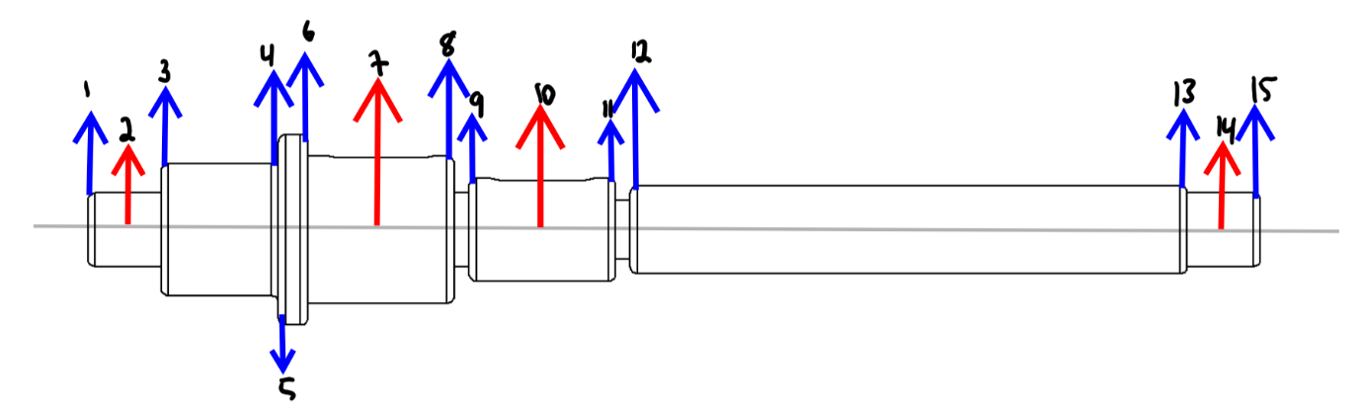

Figure 5 - Input Shaft Critical Points

### 2.3.1 Resulting Fatigue Stress Concentration Factors at the Critical Points:

**Neuber Constant:**

**For AISI 4130 steel, Sut = 87.02 kpsi**

The first factors calculated are the static stress concentration factors. These look at critical points such as fillets where there is a change in the cross-sectional area. This factor is increased by creating a larger difference in cross-sectional area, or by creating fillets with smaller radius. Each of the static stress concentration factors were calculated using tables given in the textbook.

Static stress concentration factor (normal stress, bending) [Tutorial 7, slide 16]:

Figure 6 - Table given to determine the static stress concentration factor (normal stress, bending) [Tutorial 7, slide 16]

Static stress concentration factor (shear stress, torsion):

Figure 7 - Table given to determine the static stress concentration factor (shear stress, torsion) [Tutorial 7, slide 17]

The second factor calculated is the fatigue stress concentration factor which uses the equations below. These depend on the previously calculated static stress concentration factors, the Neuber constant, and the fillet radius.

**Fatigue Stress Concentration Factor (normal stress, bending):** [Tutorial 7, slide 18]

**Fatigue Stress Concentration Factor (shear stress, torsion):**[Tutorial 7, slide 18]

At keyways the fatigue stress concentration factors are determined based on Figure 8 below. The factors depend on the shape of the keyway, as well as if the material is annealed, or quenched and drawn. Our keyways are square and the material is annealed so our Kf is 1.6 and Kfs is 1.3.

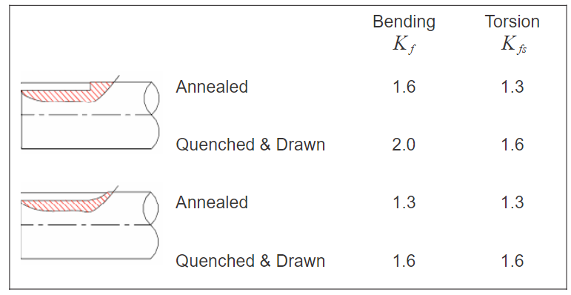

Figure 8 - Fatigue stress concentration factors for keyways [Lecture 17, Slide 9]

Final factors for determining the fatigue stresses at the critical points on each shaft were calculated and put into Tables 3 and 4 below.

Table 3 - Summary table of all factors calculated for the input shaft



Table 4 - Summary table of all factors calculated for the input shaft



### 2.3.3 Midrange Torque and Resulting Amplitude Moment at the Critical Points:

The midrange torque is the torque that is exerted on each shaft. For the input shaft, this is equal to the tangential force on the pinion multiplied by the radius. For the output shaft, the midrange torque is equal to the new toque that is achieved by the tangential force multiplied by the radius of the gear once again. The midrange torque on the input shaft is equal to 0.6315 Nm and the midrange toque on the output torque is equal to -1.6 Nm. The negative torque on the means that it is acting on the shaft in the opposite direction of the sign convention.

Since the torque on the output shaft would be the highest in the hill climb event, this is the event that was used for the calculations. Using Figure 8 through Figure 13, the moment was interpolated for using the distance of each critical point from the point on the shaft where the y-intercept is on the moment diagram. Equation 9 Amplitude moment calculation by using the magnitude of the moments in the xy and xz planes.

(9)

Table 5: Amplitude moments and midrange for each critical point on the input shaft.



Table 6: Amplitude moments and midrange for each critical point on the output shaft.



### Safety Factor at the Critical Points

Next, each critical point was analyzed to make sure that the designed shafts were usable and would not fail during the events. Using the DE-Gerber criterion with the stress concentration factors, diameter, amplitude moment, and midrange torque at each critical point, the factors of safety could be determined. There were two assumptions made for ease of calculations; the gears and shaft were assumed to be weightless and all forces, but torsion and bending were ignored.

(10)

(11)

(12)

Equation 10 and Equation 11 are terms that are used in the GE-Gerber criterion that is found under Equation 12. The ultimate tensile strength of the steel used was assumed to be 600MPa. The factor of safety, *n*, is the inverse of the right side of the equation.

Table 7 (left): Factors of Safety at Each Critical Point for the Input Shaft.

Table 8 (right): Factors of Safety at Each Critical Point for the Output Shaft.

 

## Bending Moment and Torque Diagrams:

Bending moment and torque diagrams were created for each shaft in both the YX and the ZX planes. These diagrams determined the point that experiences the greatest moment and the magnitude of that moment. Torque diagrams were also created for each of the shafts, based on torque values previously calculated for the hill climb event.

### 2.4.1 Input Shaft Diagrams

The bending moment diagrams for the input shaft determine that the maximum moment in the YX plane is 0.217 Nm, and the maximum moment in the ZX plane is 0.5951 Nm.

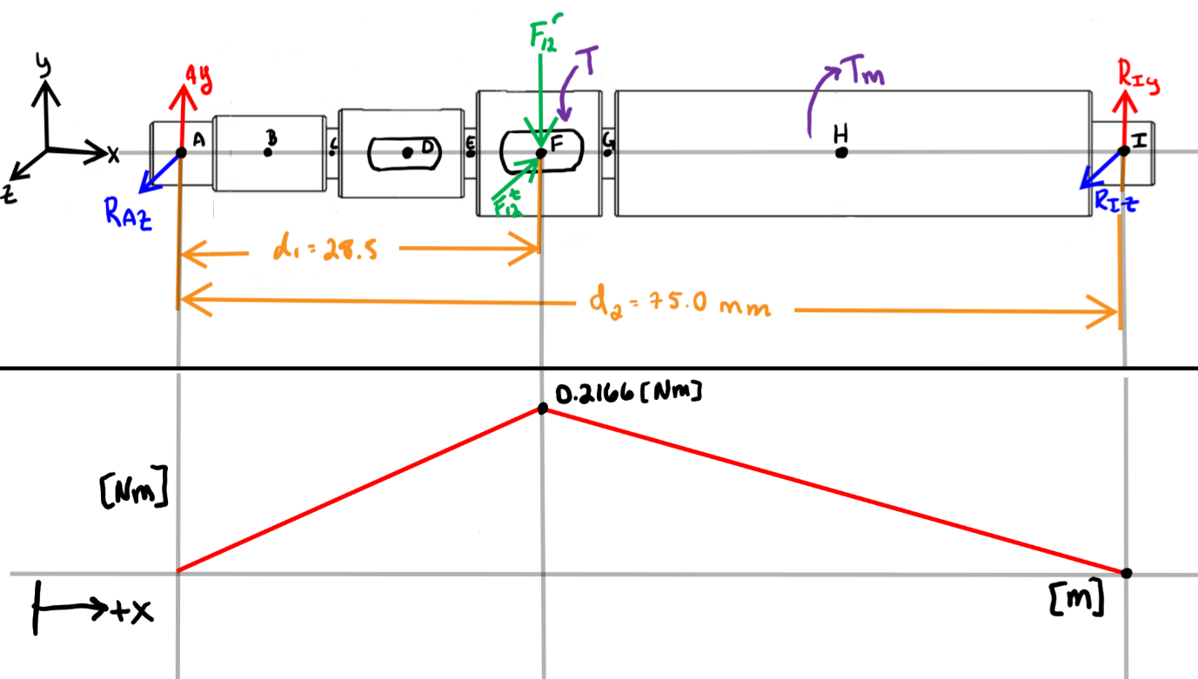

Figure 9- Bending moment diagram for the input shaft in the YX plane

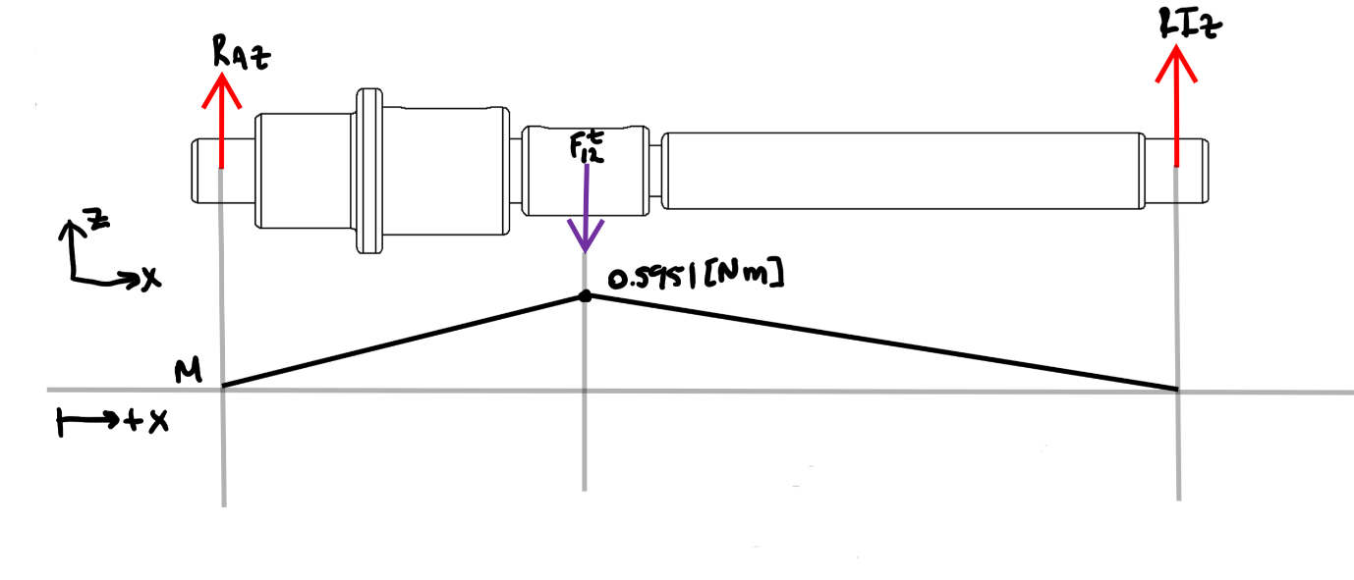

Figure 10 - Bending moment diagram for the output shaft in the ZX plane

The torque diagram for the input shaft shows the maximum torque the shaft experiences is 0.6315 Nm.

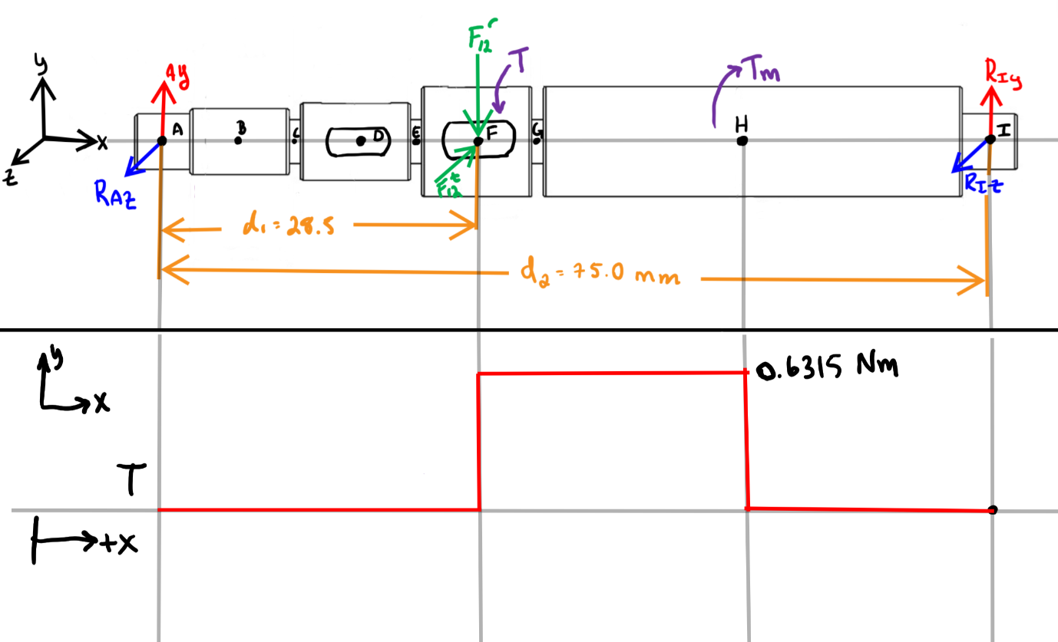

Figure 11 - Torque diagram for the input shaft

### 2.42 Output Shaft Diagrams

The bending moment diagrams for the output shaft determine that the maximum moment in the YX plane is 0.217 Nm, and the maximum moment in the ZX plane is 0.5951 Nm.

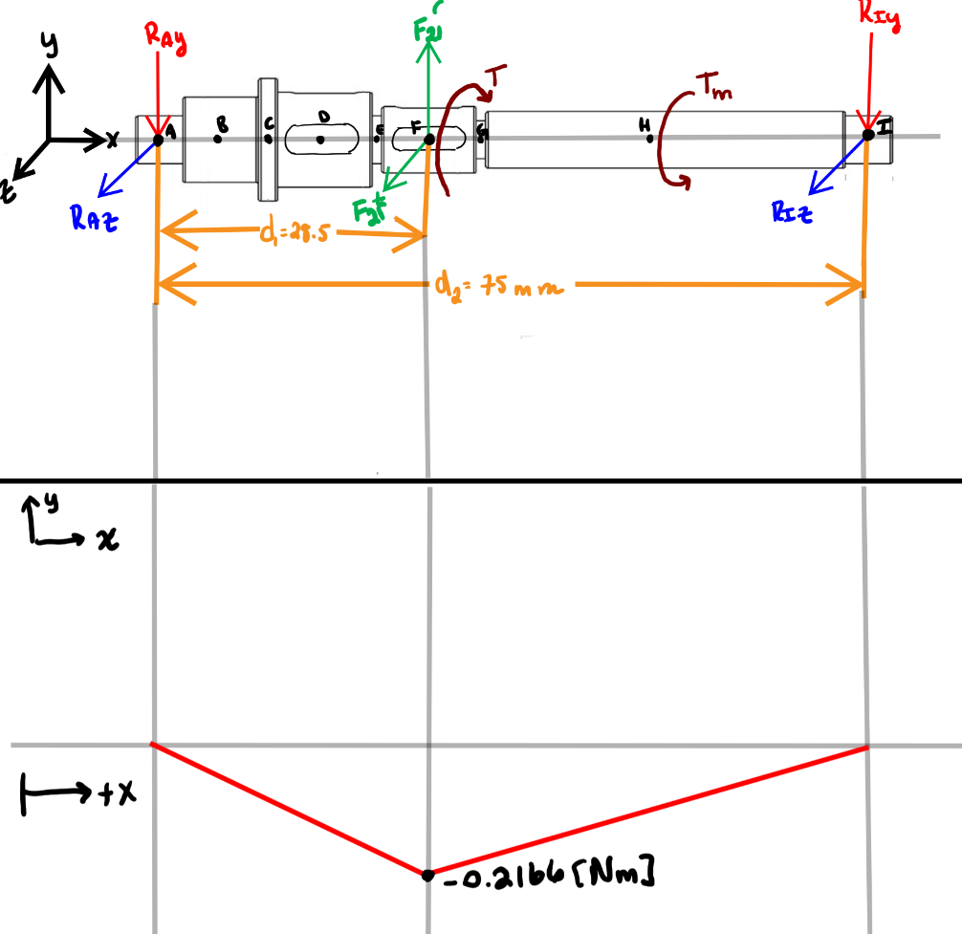

Figure 12 - Bending moment diagram for the output shaft in the YX plane

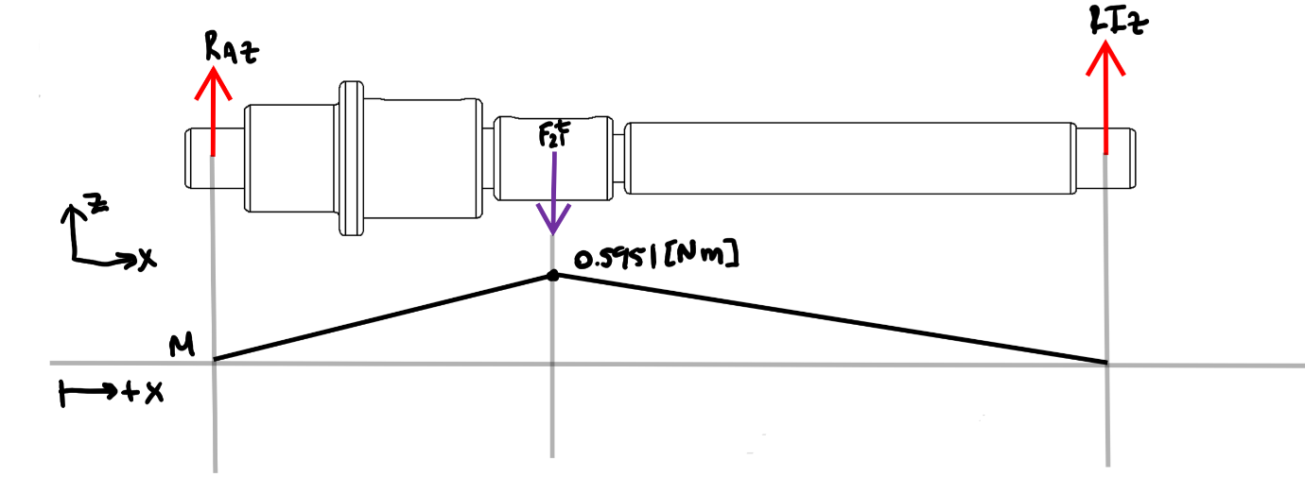

Figure 13 - Bending moment diagram for the output shaft in the ZX plane

The torque diagram for the output shaft shows the maximum torque the shaft experiences is 1.6 Nm.

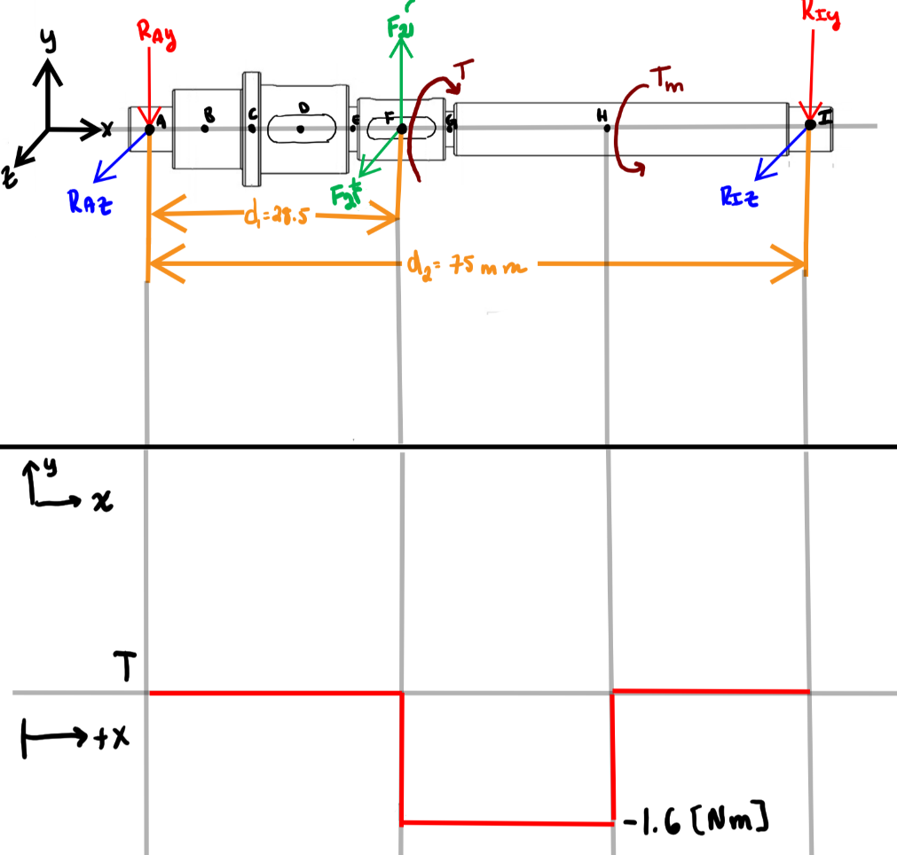

Figure 14 - Torque diagram for the output shaft in the YX plane

# Conclusion:

Considering that values are smaller for larger diameters, larger shafts will have a lower value, so the largest diameter value of is chosen. This is calculated to be 696.306 MPa for shaft diameter of 13 mm. Comprehensive FBDs were created for the input and output shafts, and unknown forces were determined by using the sums of moments and forces. These results are summarized in Table 2. Critical points were identified along the shaft length, which were shoulders, keyways, and bearings. Kt, Kts, Kf, and Kfs values for all these critical points are summarized in Table 3 and Table 4. The bending moment and torque diagrams for the input and output shafts show that the structure of the shafts are stable. To further analyze the critical points in the report and show that the structure is reliable and will not fail when subjected to the maximum bending and torsional forces, Kf and Kfs values were used along with the moment and midrange torque in the GE-Gerber criterion to estimate the safety of factor. It was found that all of the safety factors that were found exceeded 1, with the smallest safety factor approaching 3. This was the goal, as it means that the shafts are quite resistant to failure from torsional and bending forces.

Ultimately the design satisfied all the criteria and expectations of the group as the shaft design was deemed safe and stable in withstanding the forces and fatigue stress it would be subjected to throughout the events.

# Works Cited

|  |  |
| --- | --- |
| [1] | K. N. Richard Budynas, Shigley's Mechancical Engineering Design, McGraw Hill, pp. Page 360, equation number 6-25. |

# Appendix A – Python Code:

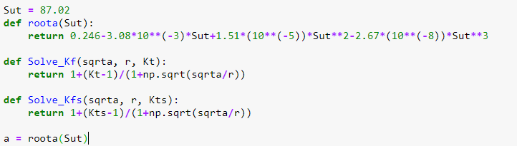

Figure 15 - Defining functions to solve for Kf and Kfs factors

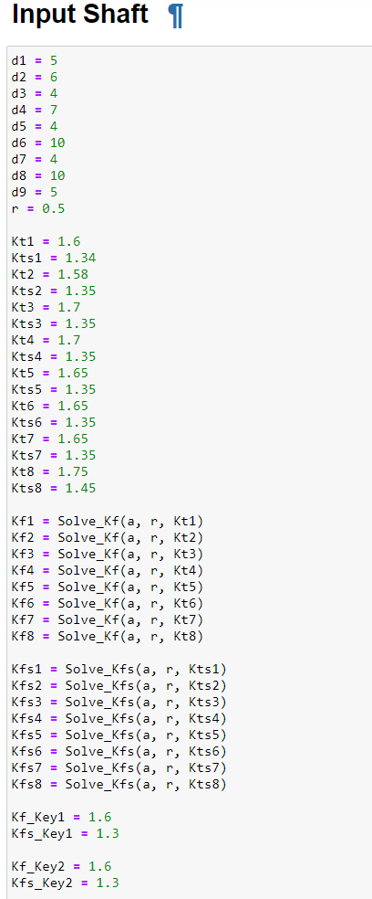

Figure 16 - Code used to calculate factors for the input shaft

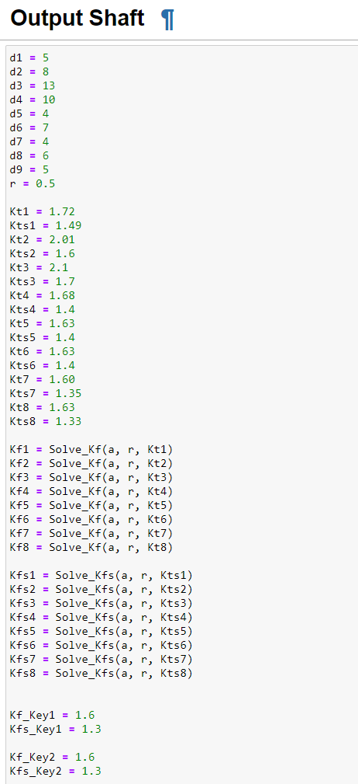

Figure 17 - Code used to calculate factors for the input shaft